

SCSR2213 NETWORK COMMUNICATIONS
Task#1: Project Setup Group 4: Linux
SECTION: 5
Lecturer: Dr. Adnan Khalid

Name | Matric Number
Garrah THabit | A24CS4013
Mohammed Abdlerahim | A24CS4026
LEE TUNG ERN | A24CS0103
MOHAMMED ALSAKKAF | A23CS4026

Table Of Contents:
Introduction 3
- Brief explanation for the task.
  - Floor Plan Design Explanation 4
    - Ground floor explanation
    - First floor explanation
- Floor Plan Design 5
- Meeting Minutes 7
- Project Marks 9

INTRODUCTION

As members of Linux, we are excited to present our very first project for the Network Communication course. The objective of this project is to design a basic yet functional network for a newly proposed two-storey building within the Faculty of Computing. This
facility will host several key spaces, including computer labs, a video conferencing room, and a student lounge, each with its own set of technical requirements.
Our main task is to develop a simple and efficient floor plan that addresses the networking needs of the building. We aim to ensure that the network layout is cost-efficient, easy to maintain, and adaptable for future expansion. Throughout the project, we will pay close attention to designing a solid network infrastructure that aligns with the faculty’s
operational goals while prioritizing security and performance.
The success of this project will largely depend on our ability to collaborate effectively as a team and to deliver a clear and functional design. By combining technical knowledge with good teamwork, we hope to produce a reliable network plan that fulfills the current
demands and anticipates future needs.

- Explanation for the Floor Design:

This is the newly designed Faculty of Computing building provides a modern and innovative learning space, built to accommodate a growing number of students and staff. It includes various essential facilities such as the academic office, faculty offices, server room, video conferencing room, four academic labs, a hybrid learning classroom, and a student lounge.
The ground floor is mainly designed to support the needs of faculty members and hybrid learning. From the upper entrance, one can immediately access the video conference room on the right side, followed by the hybrid learning space just a short distance further along the same side. Walking straight down the main hallway from this entrance, the server room can be found at the far end, accessible by taking a right turn. On the left side of this corridor, there is an entrance leading to the lecturers’ offices. For those entering from the lower entrance, the staircase and elevator are located directly to the left. Continuing straight and turning right brings you to the academic office, while the toilets are situated further down the same corridor. Another convenient entry point to the faculty offices is also available nearby. Additionally, seating areas are placed near both entrances to provide comfort for staff and students while waiting.
The first floor focuses on academic laboratories and student facilities. Upon reaching the top of the stairs, the toilets are directly in front. Turning right and following the hallway leads to the lab areas. Two general-purpose labs are positioned on the right side, while the Cisco Network Lab and the Embedded Systems Lab are located on the left. These labs are equipped with specialized areas for technical equipment, and each lab contains 30 individual workstations. At the very end of the corridor is the student lounge, designed to be a relaxing area with seating, bookshelves, and even a piano for students to use. A copier machine is also available beside the lounge for students’ convenience.

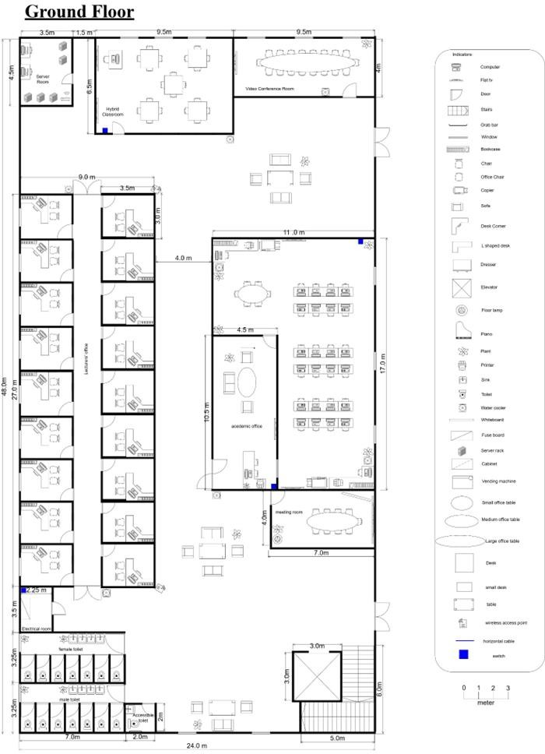

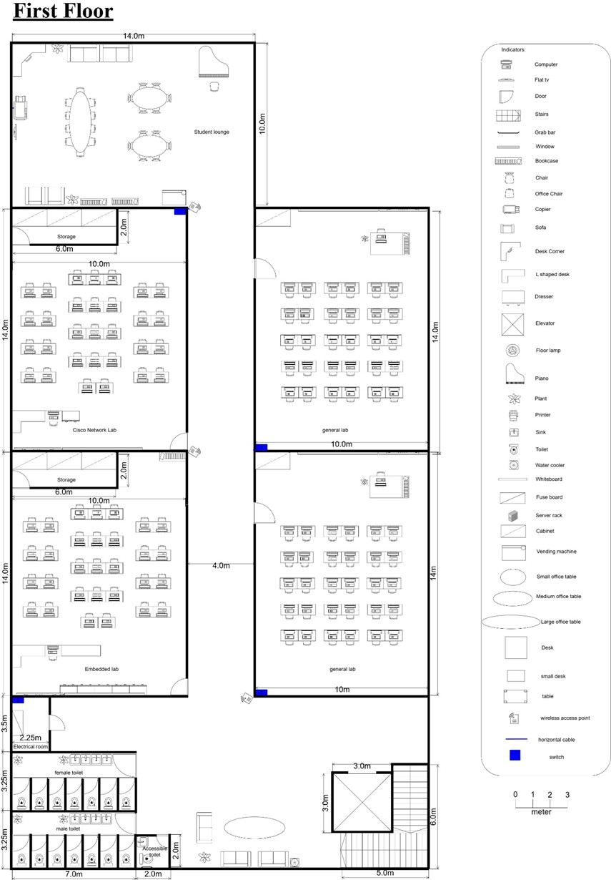

Meeting minutes
DATE | 12 April 2025 1600H
LOCATION | N28
AGENDA | - Discussion of project task 1  - Task distribution for each member  - Discussion of group name
MEETING MC | Lee Tung Ern

ATTENDANCE
Name | Time | Reason for absent
LEE TUNG ERN | 1600H | -
GARRAH THABIT | 1600H | -
MOHAMMED ABDELRAHIM | 1600H | -
MOHAMMED ALSAKKAF | 1600H | -

MINUTES
No | Item discuss | Idea / suggestion | Person in charge
1. | Group name | Group name decided to be “Linux”. | Mohammed Abdlerahim, Garrah Thabit
2. | Tool or software use to design the floor plan | Website “Draw io” decided to be used after discussion. | Garrah Thabit, Mohammed Abdlerahim, Lee Tung Ern
3. | Floor plan design | Tung Ern and Garrah designed the floor plan. Tung Ern volunteered to draw for the ground floor. Alsakkaf volunteered to draw for the first floor. | Lee Tung Ern, Mohammed Alsakkaf, Garrah Thabit
4. | Directory of floor | Tung Ern and Alsakkaf volunteered to complete the directory of floor. | Lee Tung Ern, Mohammed Alsakkaf
5. | Next meeting | 14/14 - to gather everything
 | Meeting ended | 6:00 pm

Projected Marks

TASK 1
ITEM | MARKS | EXPECTED MARKS
Group name and Members
Suggested floor plan.
Fit description – as per case study provided.
A total 30 workstations and other equipment planned for each lab
Scale: with scale
Clear and readable. Has appropriate labels

Creativity
TOTAL

